**DBMS ASSIGNMENT-3**

**BY: GROUP 12**

**JAGADEESH C (18BCS033)**

**DARSHAN R P (18BCS023)**

**ARUN KUMAR S M (18BCS013)**

**G NIKHIL KRISHNA (18BCS030)**

**KUNCHARLA GIREESH KUMAR (18BCS035)**

**KUMPATLA SAI GANESH NAIDU (18BCS044)**

1. **SHOW HOW TO CREATE AND DROP DATABASE**

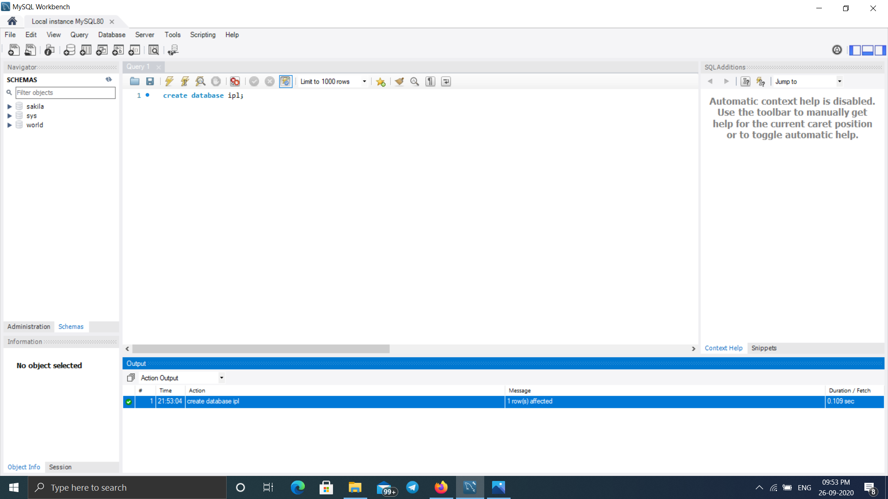

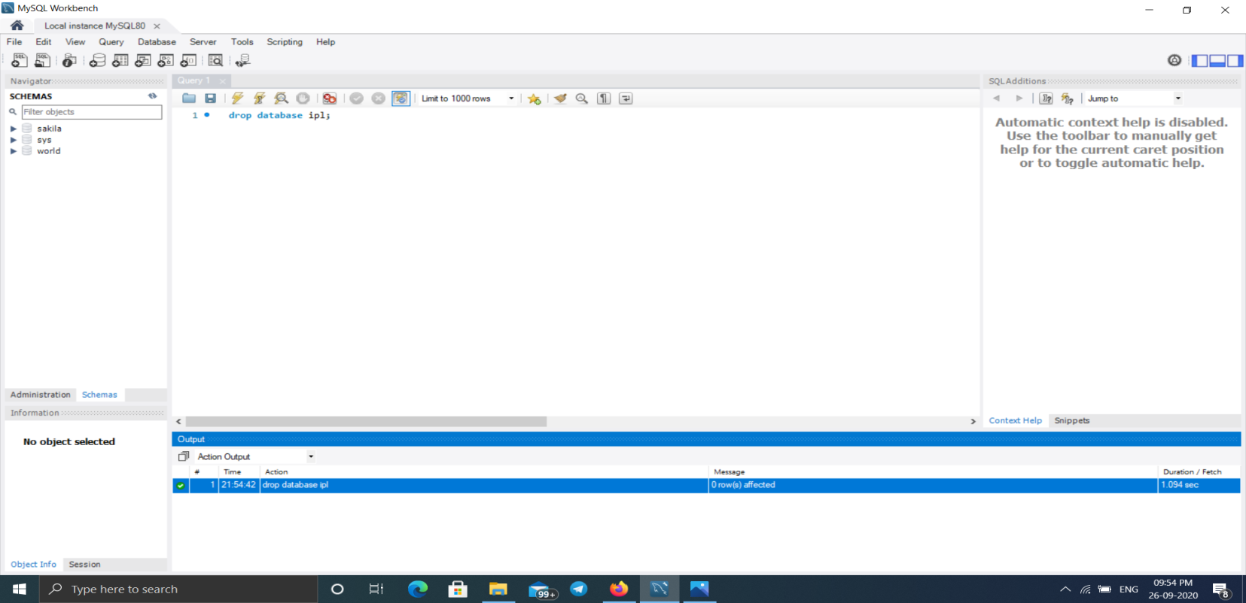

1. **SHOW ALL THE DATABASES ARE IN THE SYSTEM**

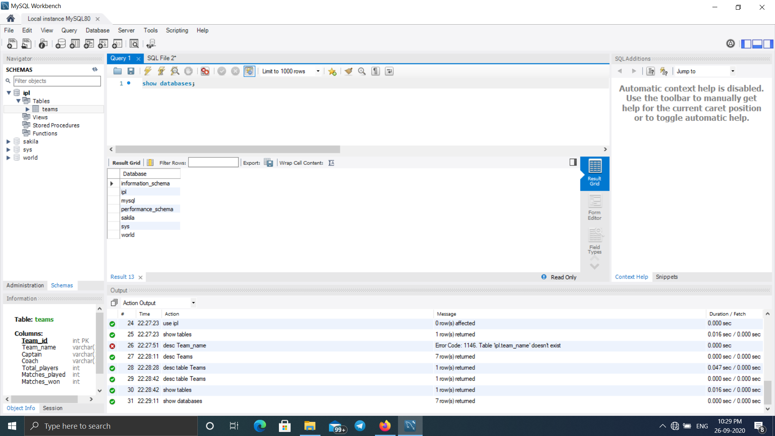

1. **CREATE TABLE FOR YOUR DATABASE**

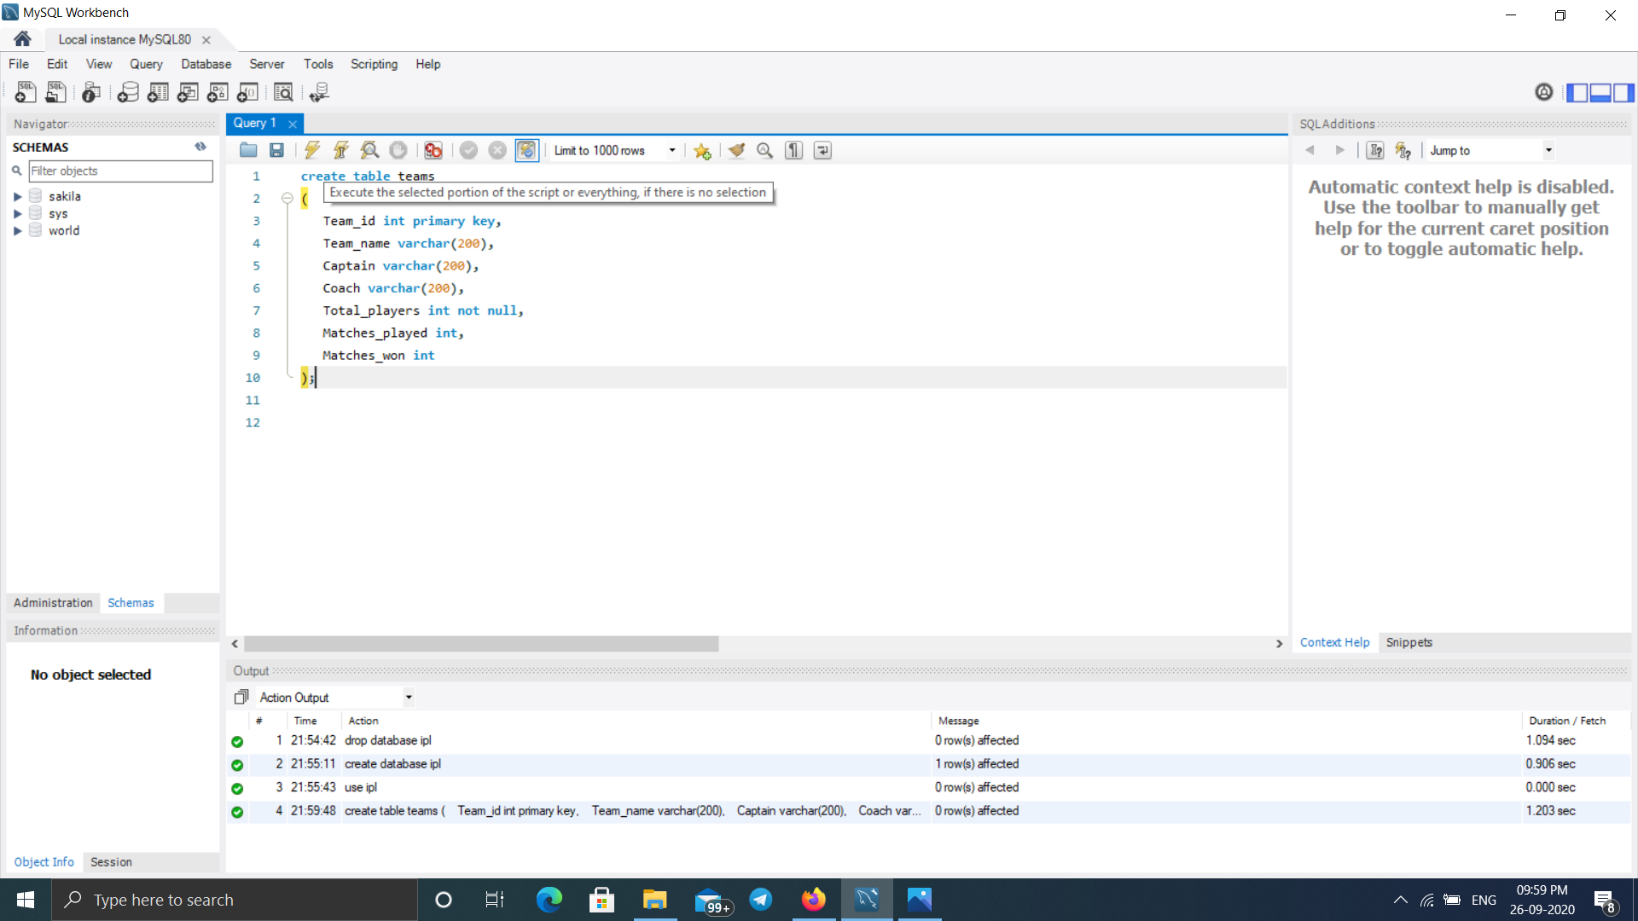

1. **SHOW HOW SELECT CAN BE USED FOR CREATING TABLE**

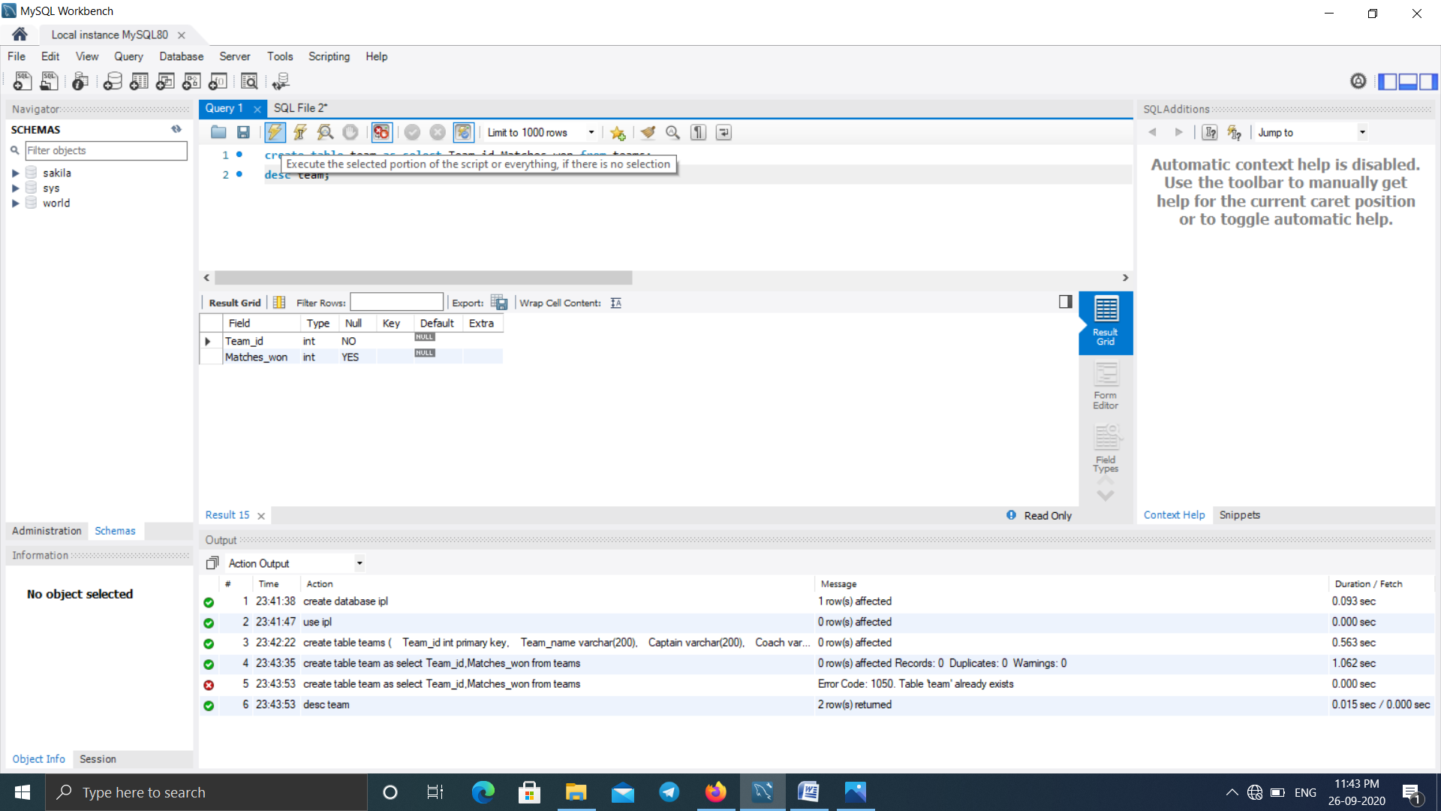

1. **DROP TABLE**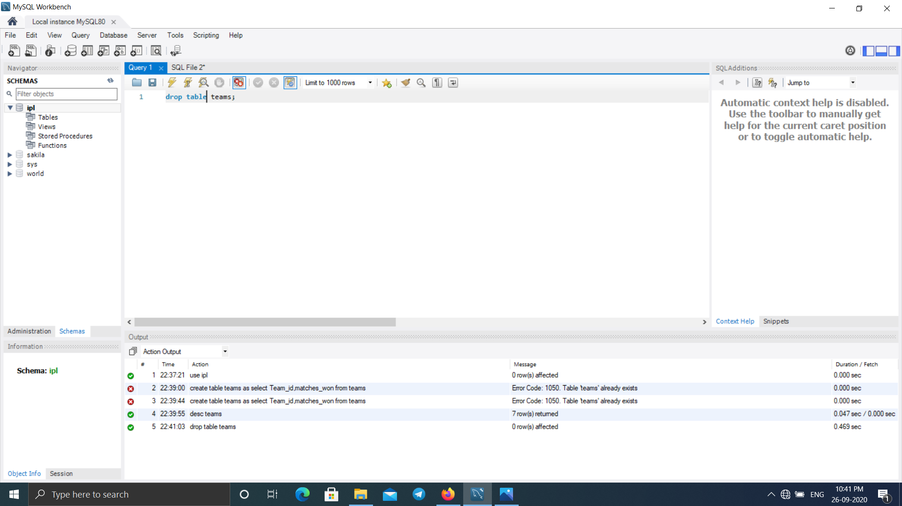
2. **SHOW HOW TO CHECK THE SCHEMA OF THE TABLES**

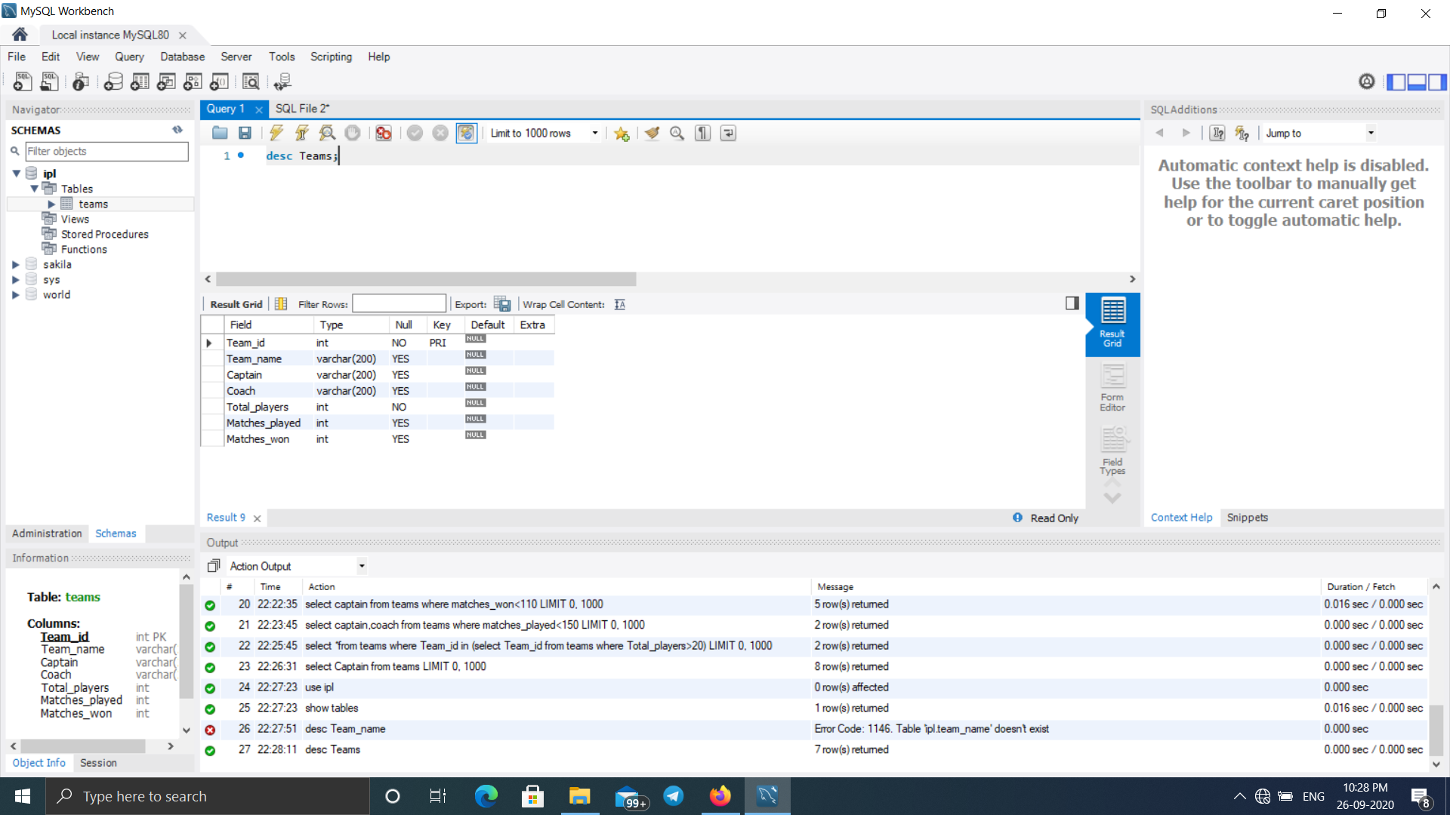

1. **SHOW ALL THE TABLES FROM THE DATABASE**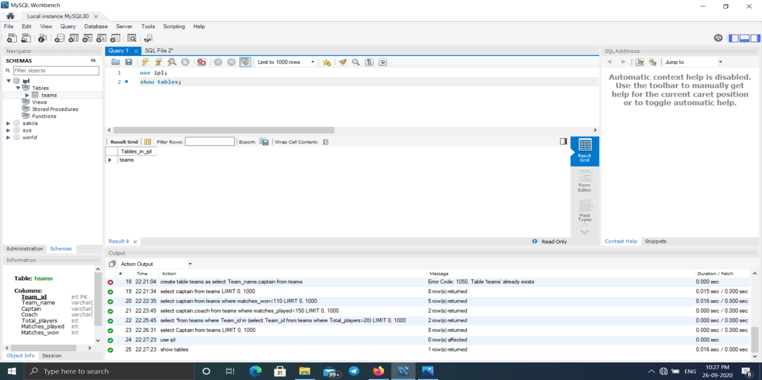
2. **INSERT 5-10 ROWS IN EACH OF THE TABLES OF YOUR DATABASE**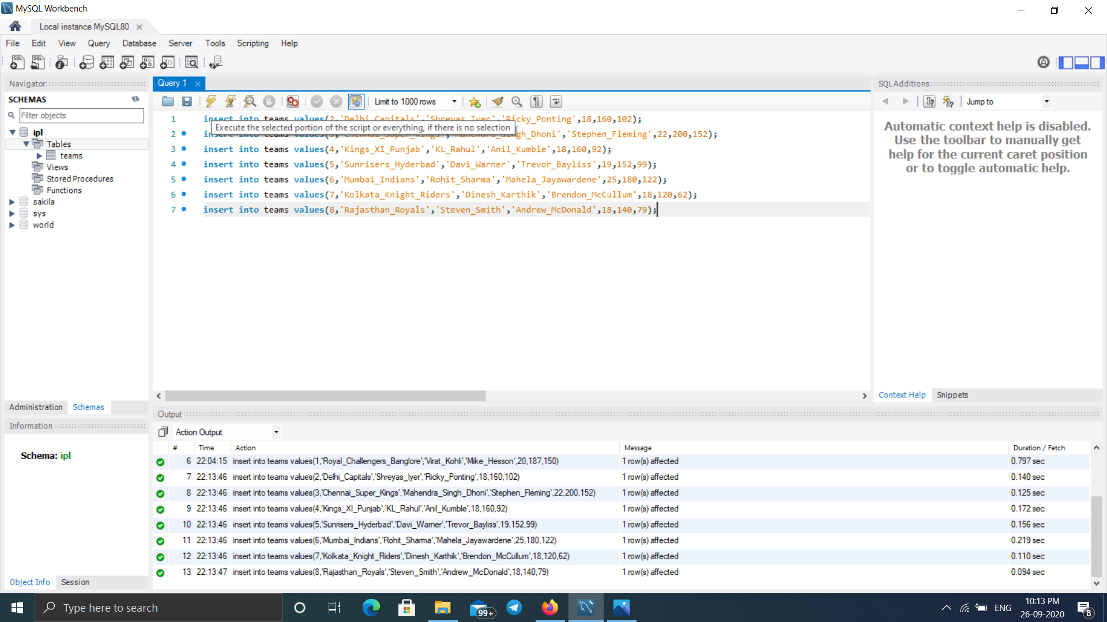
3. **SHOW USAGE OF SIMPLE SELECT STATEMENT**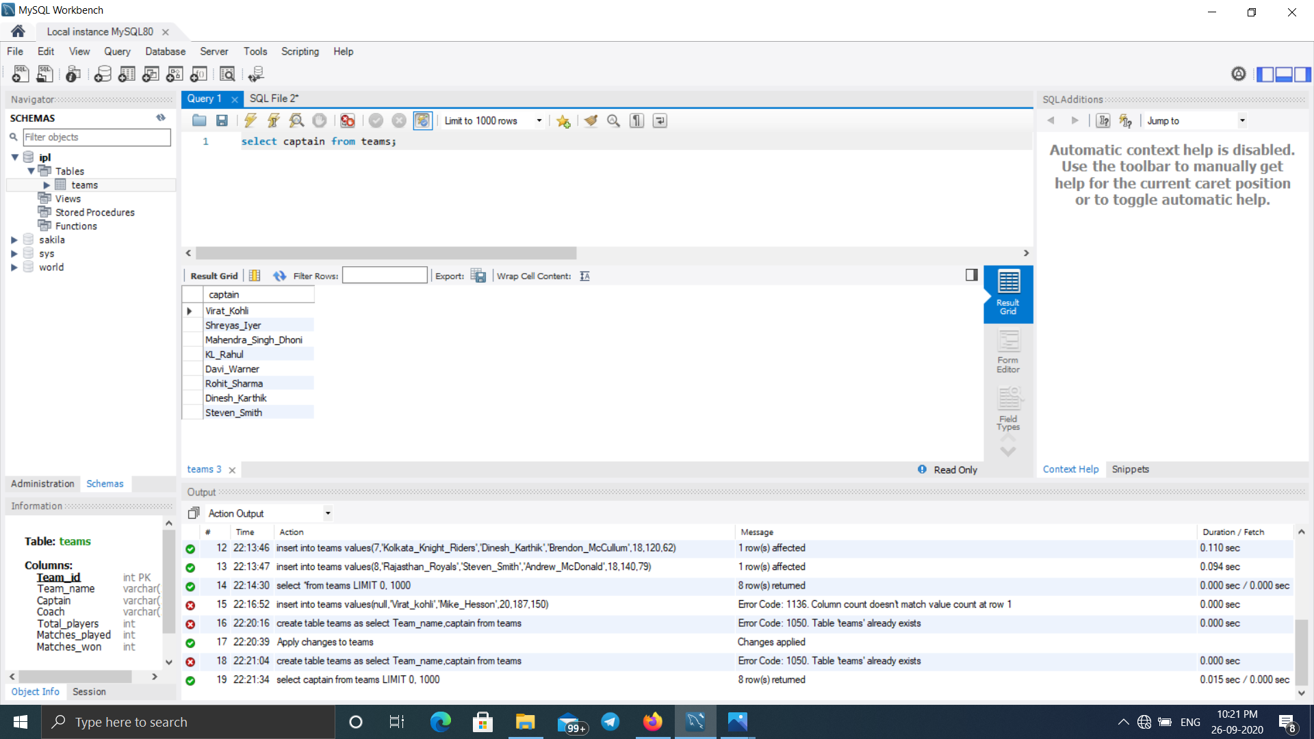

**10.SELECT STATEMENT USING RELATIONAL AND LOGICAL OPERATORS**

**A)**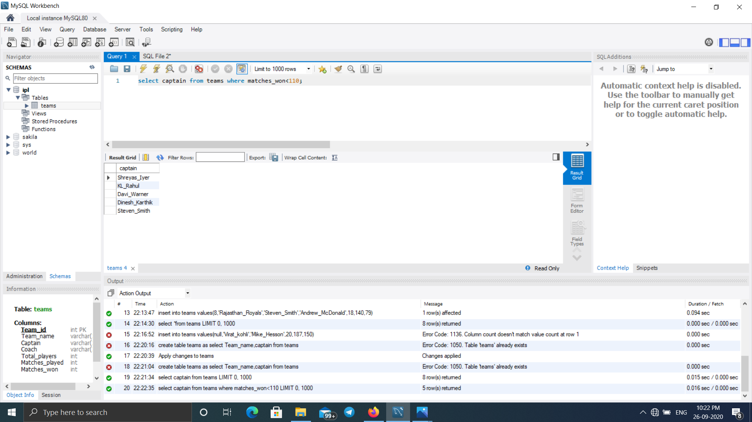

**B)**

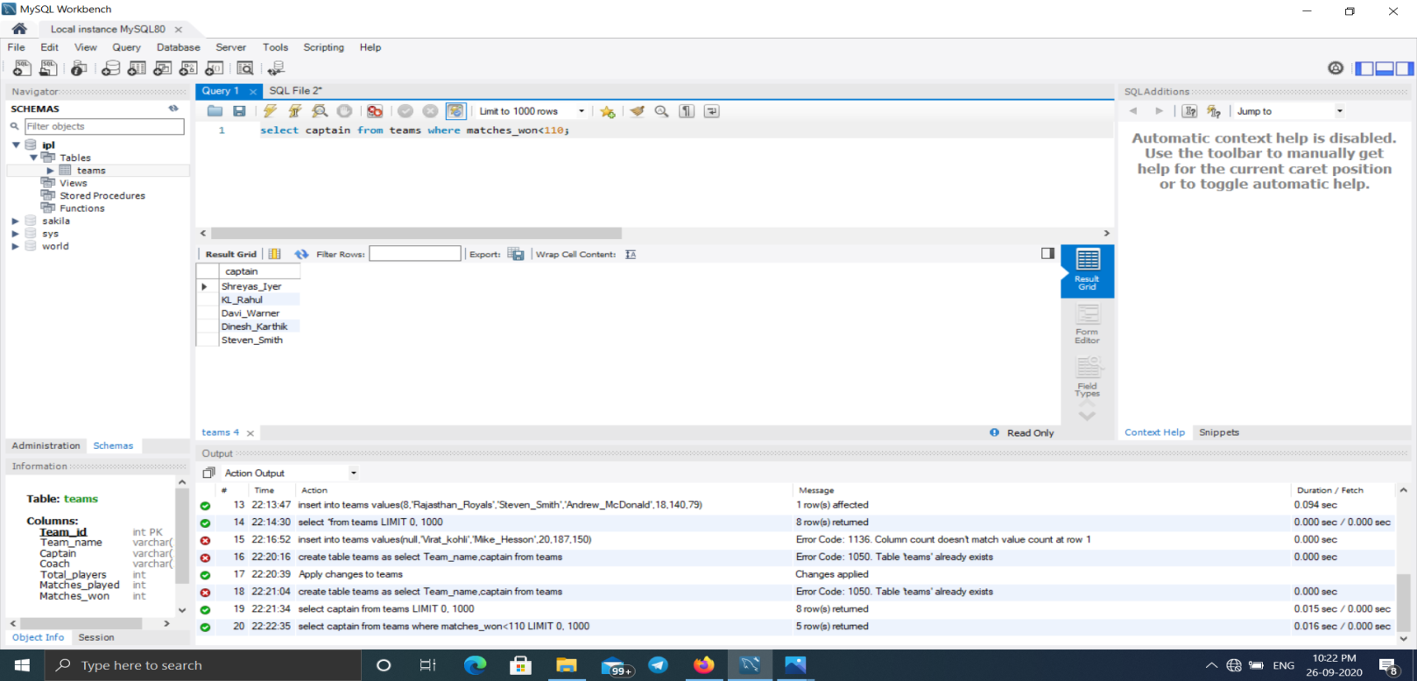

**11.ONE SIMPLE SUBQUERY USING SELECT**

